TSG- delete multiple functions for Infoblox NIOS  
  
1. Go to your workspace and select logs.  
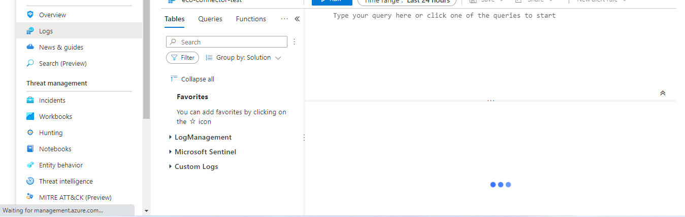

 2. Click on **Functions**and search for “Infoblox”. All the functions starting with “Infoblox” will be visible –

4. Delete all the functions starting with “Infoblox” one by one. Select the function and delete. Repeat this step for all the 21 functions starting with Infoblox.

5. After Deleting all the functions. It will take 5-10 min to reflect.

6. Reinstall the Infoblox NIOS solution from Content hub.

